Interim Release Demonstration:
** In class - put nothing here **
Items in red are corrected for regrade of Interim Release

Design Approach:
Our design approach employs the Model-View-Controller (MVC) design pattern, and Layered Architecture for our overall structure. For our implementation of MVC, the Model encompasses AI responses, hotel recommendations, and restaurant recommendations, housing data and business logic. Each service, acting as a Controller, strategically manages user input and actions. The presentation layer serves as the View, engaging with users and displaying results. This MVC pattern results in classes with high cohesion and a structure that allows easy addition of features.
For our design architecture, we implemented a Layered Architecture, which consists of a Presentation Layer, Domain Model, and Service Layer. The Presentation Layer handles HTTP requests and communicates with users, while the Domain Model forms the core with key classes like specifications, hotels, and restaurants. The Service Layer consists of microservices, such as RestaurantService and HotelService, which break down the system for improved scalability. An API gateway is integrated into the architecture to route and aggregate responses efficiently, adding a layer of flexibility to the overall design.

Sequence Diagrams:

Use Case 1 : Questionnaire
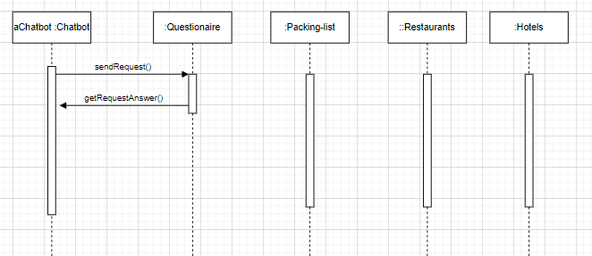
Use Case 2 : Restaurant Recommendations
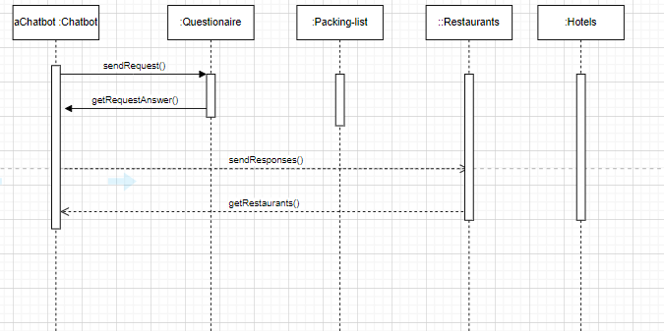
Use Case 3 : Packing List
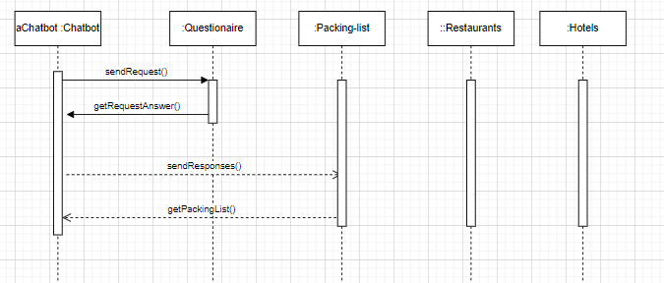

Use Case 4 : Hotel Recommendations
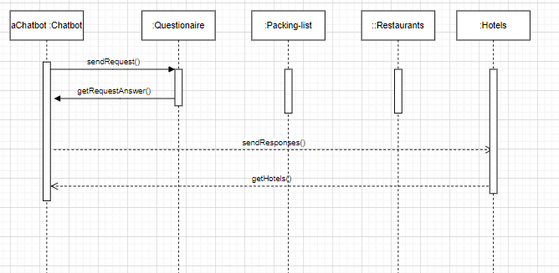

CRC Cards:

Class Name: TravelChatBot
- Responsibilities: Receives and processes user input. Determines travel requirements, including destination, dates, and preferences. Collaborates with external services to fetch travel information (restaurants and hotels). Generates responses to user queries.
- Cohesion Rating: 7. It exhibits informational cohesion as it encapsulates core functionalities related to the travel chatbot's interaction and information retrieval.
- Collaborators:
  - User (Coupling Rating: 1 - Data coupling)
  - RestaurantFetcher (Coupling Rating: 1 - Data coupling)
  - HotelFetcher (Coupling Rating: Good - Data coupling)

Class Name: User
- Responsibilities: Provide input to the chatbot. Receives responses from the chatbot.
- Cohesion Rating: 7. It exhibits informational cohesion for user interaction.
- Collaborators:
  - TravelChatBot (Coupling Rating: 1 - Data coupling)

Class Name: RestaurantFetcher
- Responsibilities: Retrieves restaurant information based on user requirements. Filters and processes restaurant data.
- Cohesion Rating: 7. It exhibits informational cohesion by concentrating on restaurant data retrieval and processing.
- Collaborators:
  - TravelChatBot (Coupling Rating: 1 - Data coupling)
  - External restaurant data source (web scraping) (Coupling Rating: 2 - Stamp coupling)

Class Name: HotelFetcher
- Responsibilities: Retrieves hotel information based on user requirements. Filters and processes hotel data.
- Cohesion Rating: 7. It exhibits good informational cohesion as it focuses on hotel data retrieval and processing.
- Collaborators:
  - TravelChatBot (Coupling Rating: 1 - Data coupling)
  - External hotel data source (web scraping) (Coupling Rating: 2 - Stamp coupling)

Cohesiveness - Degree of Interaction within Modules:
- 7 - Informational cohesion (Good)
- 6 - Functional cohesion
- 5 - Communication cohesion
- 4 - Procedural cohesion
- 3 - Temporal cohesion
- 2 - Logical cohesion
- 1 - Coincidental cohesion (Bad)
Coupling - Degree of interaction between two modules
- 1 - Data coupling (Good)
- 2 - Stamp coupling
- 3 - Control coupling
- 4 - Common coupling
- 5 - Content coupling (Bad)
Static Class Diagram: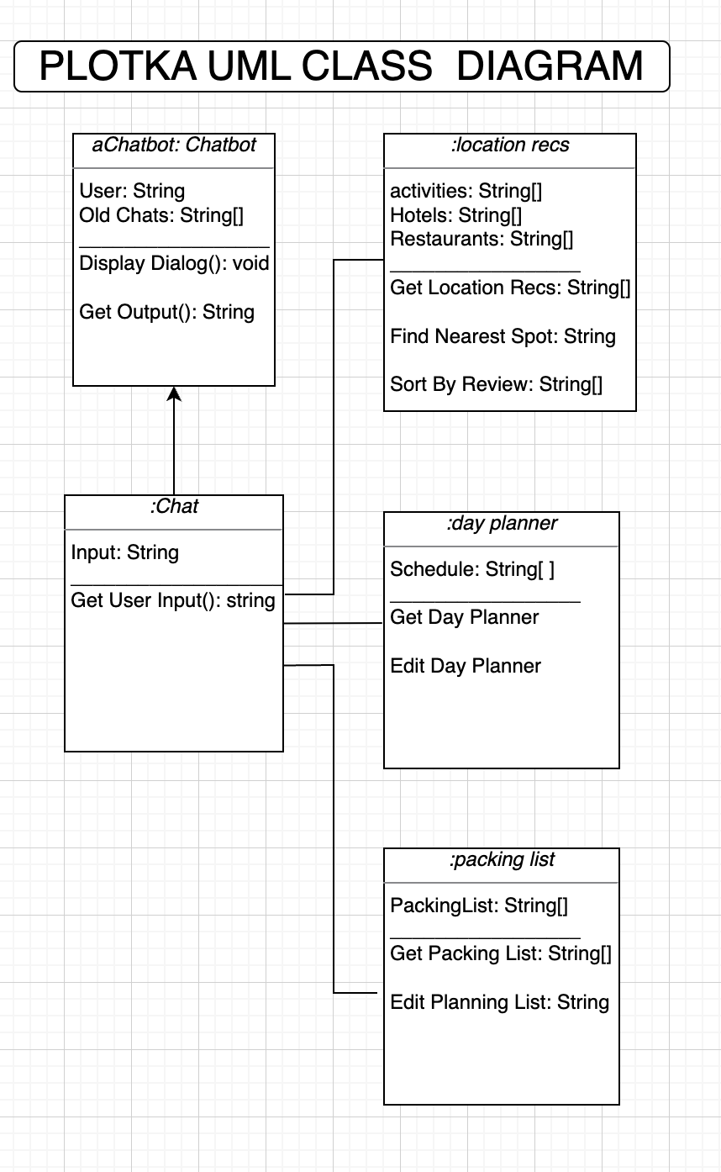
Mock-up Interface Test Plan:
We will test our product by asking our testers to provide the following inputs based on the questions asked by the chatbot:

Question | Input for testers to provide
Where do you want to travel? | Miami
When does your trip start? | March 1st
When does your trip end? | March 10th
How many people are going? | 4
Any more specifications? | No

This will be to test that they all get either the same or very similar outputs from the chatbot. Next, we will ask them about the user interface. We will ask “Was it easily accessible?”, “Were you able to figure out how to use all the features?”, and “What would you like us to change?”. We will then record these answers in a table/spreadsheet. Here is our schedule (tests will be done first and interviews immediately after in the same sitting):

Tester | Date | Time of Interview and Test
1 | 11/8 | 11:00 Am
2 | 11/8 | 11:30 am
3 | 11/9 | 6:00 pm
4 | 11/9 | 6:30 pm
5 | 11/10 | 1:00 pm

Status Report (Up until this point):
Up until this point we have completed every requirement listed in Sprint 1 and 4. This week we focused on completing the requirements for a regraded Sprint 4 and the Interim Release. For Sprint 4, we had to add some output to our mockup presentation, update our status report, add testing examples for user stories, separate our supplemental specification, create a much more detailed and complete work breakdown structure (WBS), and improve use case readability. We then began focusing on our Interim Release. For the interim release, we will present our product up to this point in class. However, the things we completed on paper were the design approach, sequence diagrams, CRC cards, a static class diagram, and our mockup interface test plan.

Week 8:
Accomplishments | Notes | Date
Fix our Sprint 4 | Try to modify it for a better grade. | 11/01
Add the missing testing parts to each of the user stories. | Modified in orange | 10/31
Add more details for the flow of events in use cases. | Modified in orange | 10/31
Front-end visuals finished, added logo and chat feature. | Finished the front end on the git hub. | 11/01
Add a section for each object output。 | Work in progress. Output shows in the chat bot. Need to parse through to store in each object to be put in separate boxes. | 11/01
Finish diagrams for interim release | - Sequence diagrams  - Static class diagram | 10/31
Fix code structure | Currently all of our objects are in the same file | 11/1

Week 7:
Accomplishments | Notes | Date
Review the Sprint 4 | Try to modify it for a better grade. | 10/24
Add the missing testing parts to each of the user stories. | Modified in orange | 10/24
Add more details for flow of events in use cases. | Modified in orange | 10/24
Front-end visuals finished |  | 10/24
Improve Sprint 4 WBS |  | 10/25
Improve Sprint 4 Supplemental Specification |  | 10/25
Improve Sprint 4 Prototype/Presentation |  | 10/25
Work on Prompt engineering to get desired outcomes |  | 10/25

Week 6:
Accomplishments | Notes | Date
Check the updated schedule | The schedule was updated in Sprint 4 | Oct 16th
Working on having a user-friendly front-end | Try to fix the bugs in the existing features | Oct 16th
Working on API integrations | Implement API to chat | Oct 16th
Finalize deployment diagram | For sprint 4 | Oct 13th
Finalize Work Breakdown Structure (WBS) | For sprint 4 | Oct 13th
Finalize Use Cases | For sprint 4 | Oct 13th
Submit sprint 4 |  | Oct 13th

Week 5:
Accomplishments | Notes | Date
The finished design of front-end web application | It needs to add some API into it. It still cannot work. | Oct 11th
Finished our User Stories for Sprint 4 |  | Oct 13th
Finish Supplemental Specifications |  | Oct 12th
Working on our Product Interface MockUp for Sprint 4 | Have a site close to ready for product mockup. Need to record our video of using the interface | Oct 12th
Deployment Diagram for Sprint 4 | Created a diagram of the software and how our software works with user | Oct 12th
Use Cases (80% complete) for Sprint 4 | Need to finish and finalize for sprint 4 | Oct 13th
Work Breakdown Structure (WBS) for Sprint 4 | Need to finish and finalize for sprint 4 | Oct 12th
Updated Project Schedule for Sprint 4 | Adjusted our Project Schedule Accordingly based on the progress we have made so far. | Oct 12th

Week 4:
Accomplishments | Notes | Date
Working on User Stories and Sprint 4. | It’s part of Sprint 4 Deliverables (due on Oct 13th) | Oct 3th
Redesigning the webpage | Need more modification | Oct 3th
Met after class. Reviewed and modified our schedule. |  | Oct 3th
Resubmitted the Sprint 1. Rewrote the vision business case and the vision risk, and did other modifications | Waiting for the new score. | Oct 2th

Week 3:
Accomplishments | Notes | Date
Start User Stories | It’s part of Sprint 4 Deliverables (due on Oct 13th) | Sep 25th
The basic webpage is done | Need more modification | Sep 25th
Move the coding work to the site Glitch |  | Sep 25th
Learn how to use Postman and test some basic api on it | done | Sep 25th
Meet after class | done | Sep 25th
Review the Sprint 1 (82/100) |  | Sep 26th

Week 1 & 2:
Accomplishments | Notes | Date
Vision Statement | Plotka vision statement | 9/21
User Scenarios | Defined by Prof. Sturman | 9/15 (in class)
Project Schedule | Plans for Project | 9/21
Github created | GitHub Repository | 9/12
Plotka Discord Server created | N/A | 9/19
Work Assignment | Assigning works | 9/19
The basic structure for our project | Including frontend, backend, and web socket | 9/19

Contributions Summary:

Arnav Pawar:
- Created Sequence and Status Diagrams
- Worked on backend development

Alex Litchfield:
- Created the Mockup Interface Test Plan
- Wrote status report

Anson Decker:
- Created CRC Cards
- Helped with sequence diagrams

Yuecheng Liu:
- Finished up code snippets
  - Top10 restaurants
  - Top10 hotels
- Edited CRC Cards
- Helped with Design Approach

Ziqun Wang:
- Finished up code snippets
  - Flights information
  - Top10 restaurants
  - Top10 hotels
  - Build a web socket for the project

Yihan Shao:
- Wrote Design Approach
- Fixed errors in the front end
  - API response
  - Submit and begin the function

